**NOMBRE:** OMAR MEJÍA

**1.REALIZE THE REGISTRATION**

**2. Create a Repository**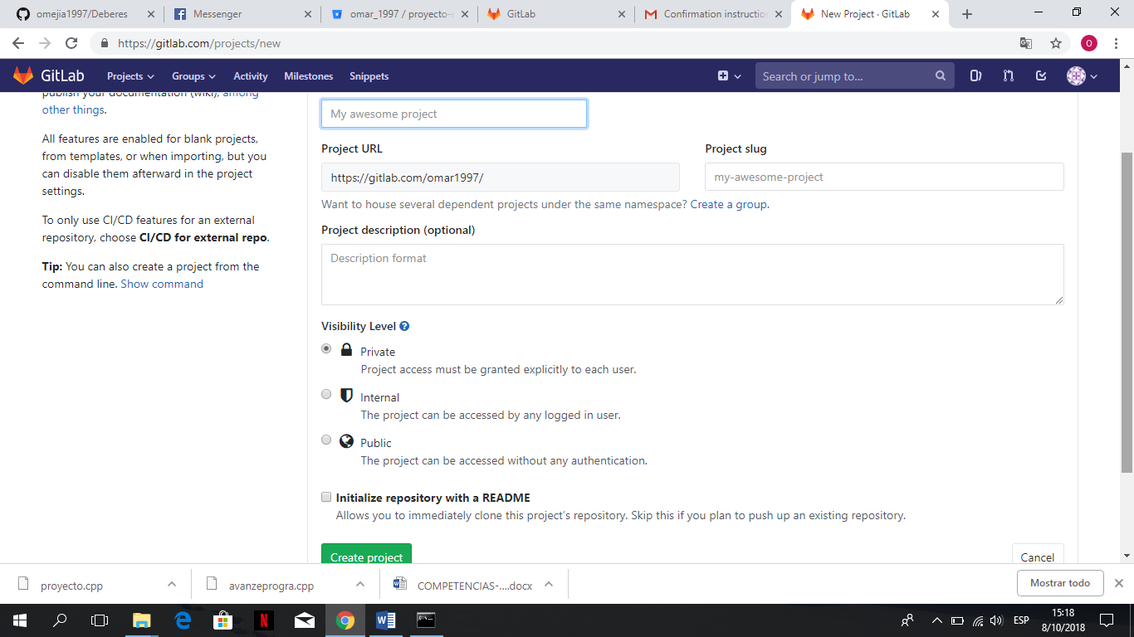

**3. Copy the commands in the CMD**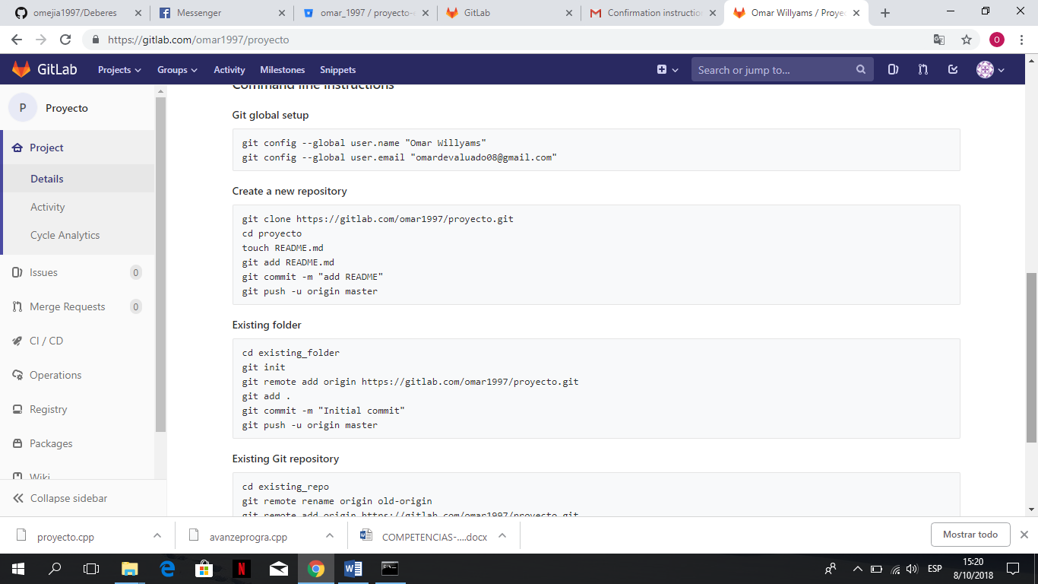

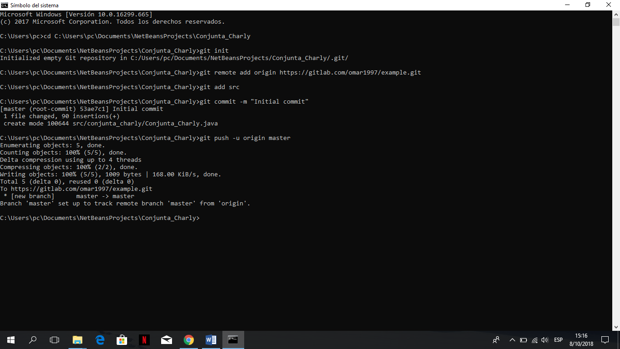

**4. Confirm and go, our code has been uploaded**